**Report On “Har Ghar Tiranga Programme Under Azadi Ka Amrit Mahotsav**”

**DAY AND DATE:** 15-08-2022, Monday

**TIME:** 01:30 PM onwards

**OBJECTIVE:** For creating awareness among the students for the country under the tagline of Azadi Ki Amrut Mohatsav where an initiative was organized of Har Ghar Tiranga by SPPU.

**NO OF STUDENTS PARTICIPATED:** The event was organized by the PDEA College of Architecture for B.Arch. students (1st ,2nd, 3rd,4th year), teaching and Non-Teaching Staff.

**BRIEF:**  Savitribai Phule Pune University has taken an initiative under the Azadi Ki Amrut Mohatsav the program **“HAR GHAR TIRANGA”** to make the students aware of the independence of the country. At PDEA College of Architecture the program was conducted where teaching, non-teaching and students participated in the event. A web-portal <https://harghartiranga.com/>where the participants need to upload the details of the event and an e-certificates where issued.

All the teaching, non-teaching and students actively participated in the event where we took photographs of students, faculties and non-teaching with the Tiranga Flag. The entire event was done hand in hand with the students and faculty members.

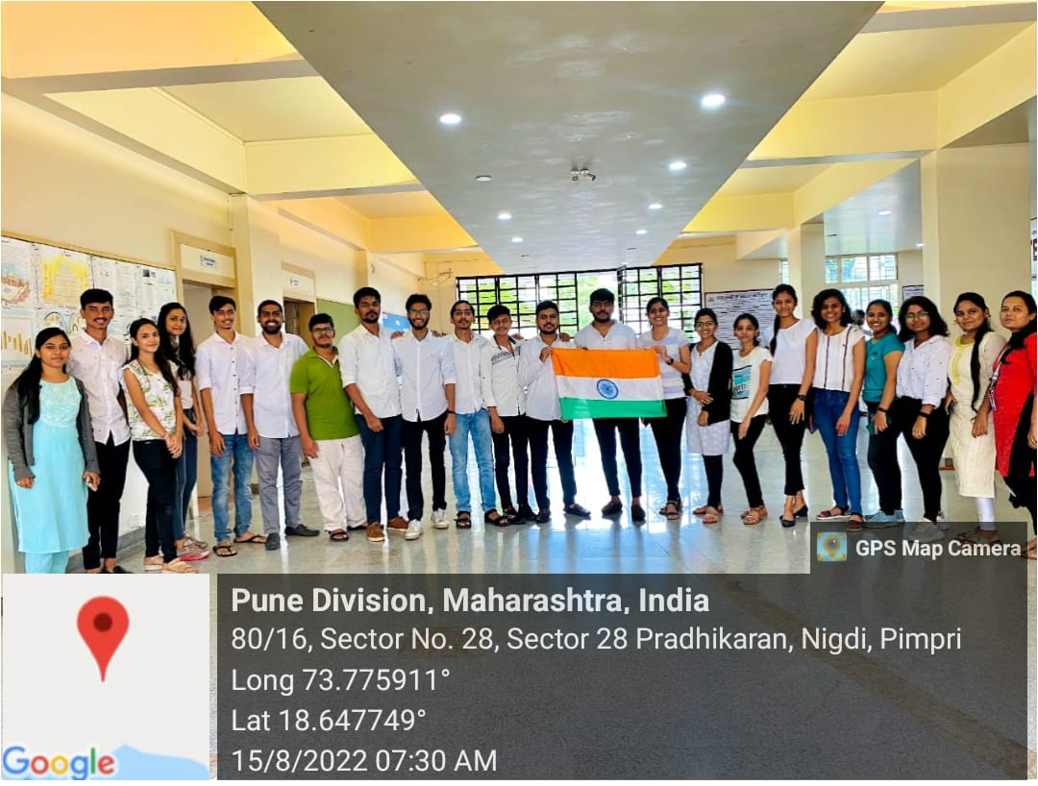

All year students group photo with flag

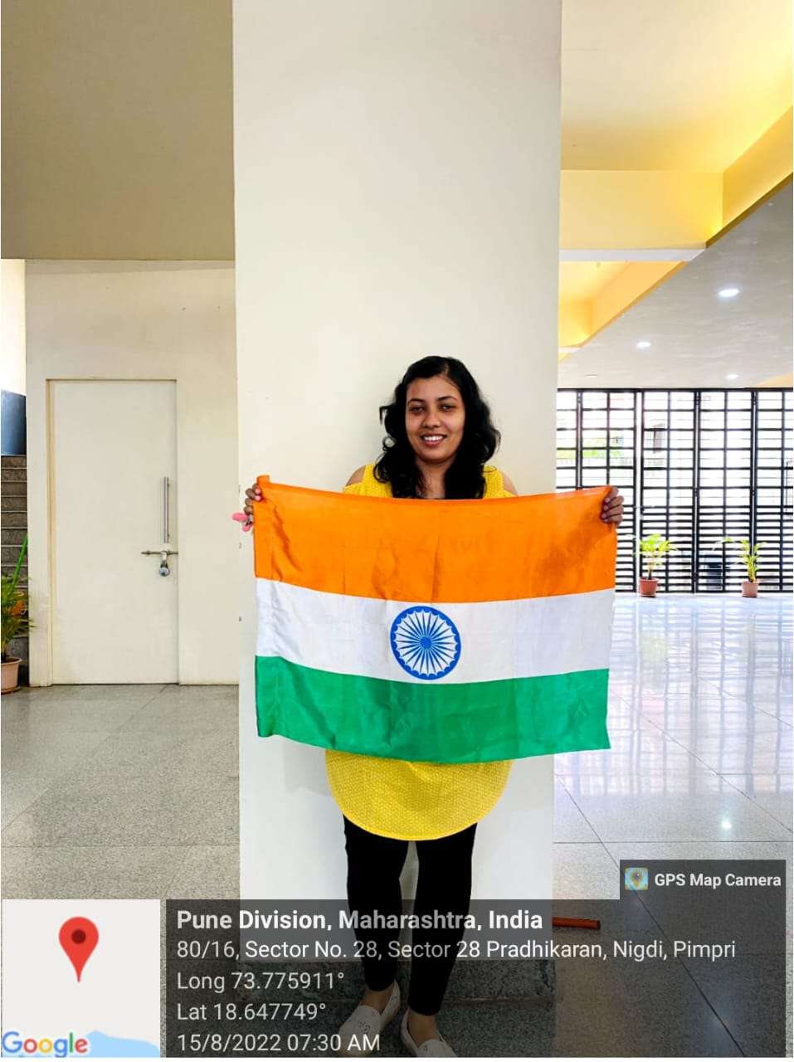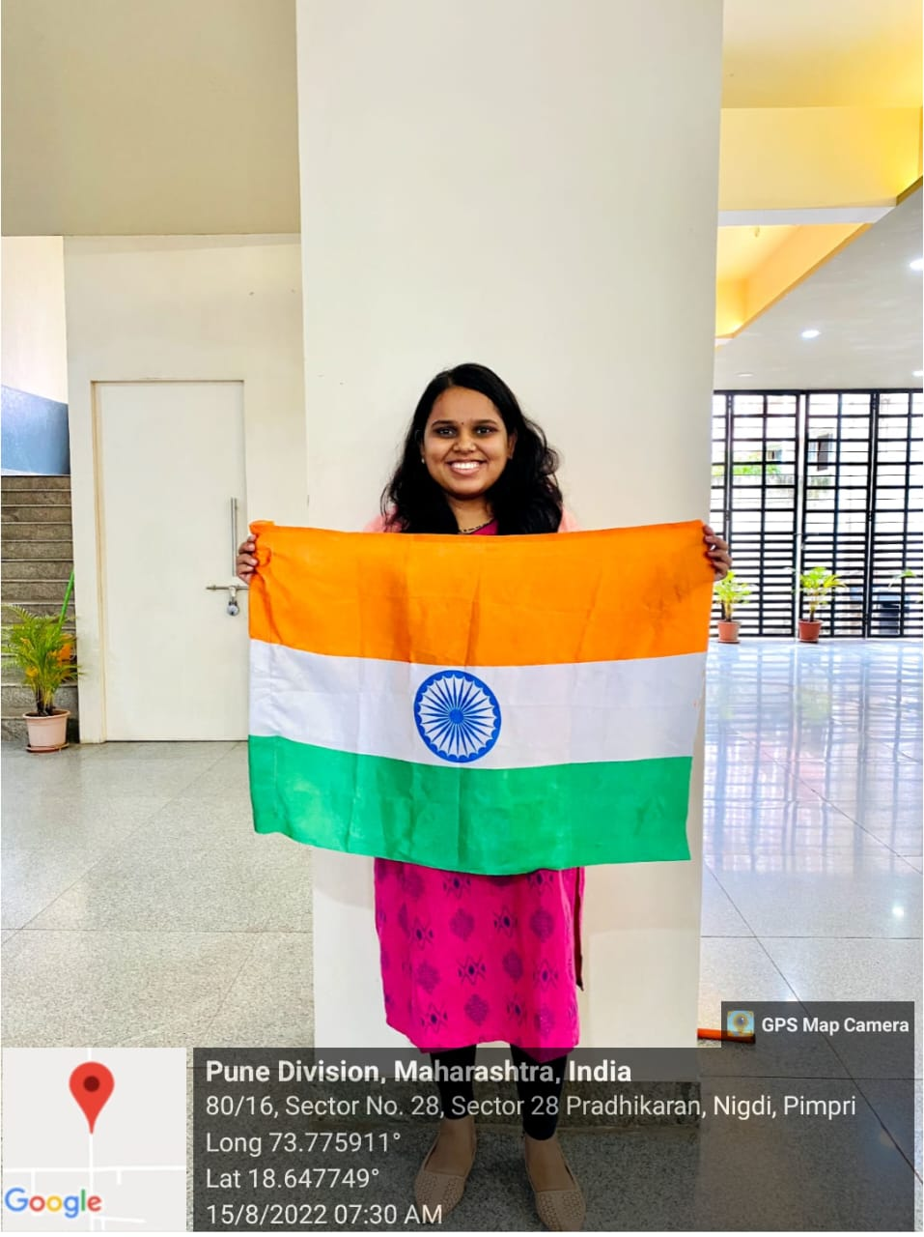

Faculties taking photo with flag.

**Report by:**

**Er. Swati Bansode**

**Assistant Professor, PDEA College of Architecture.**

**OUTCOME**

The "Har Ghar Tiranga" program organized by Savitribai Phule Pune University as part of the Azadi Ki Amrut Mohatsav initiative aimed to instill awareness about the country's independence among students. At PDEA College of Architecture, the program was successfully conducted with active participation from teaching, non-teaching staff, and students. Utilizing the web portal <https://harghartiranga.com/>, participants were able to upload details of the event, facilitating seamless documentation and record-keeping. Additionally, e-certificates were issued to acknowledge the participation of individuals, further incentivizing engagement. The event itself was marked by enthusiastic participation from all stakeholders. Students, faculty members, and non-teaching staff actively took part in various activities, including posing for photographs with the Tiranga Flag. This collective involvement underscored the sense of unity and patriotism within the college community. The collaborative effort demonstrated during the event, with students and faculty members working hand in hand, exemplified the spirit of teamwork and camaraderie. By fostering a sense of national pride and solidarity, the "Har Ghar Tiranga" program contributed to promoting a deeper understanding and appreciation of India's independence struggle among the college community. Overall, the outcome of the event was highly positive, reflecting the successful implementation of the program's objectives and the active engagement of participants. The event not only commemorated India's rich heritage of independence but also reinforced the values of unity, patriotism, and collective responsibility among students and Staff of PDEA clg of Architecture

Top of Form